Jenkins Master Slave
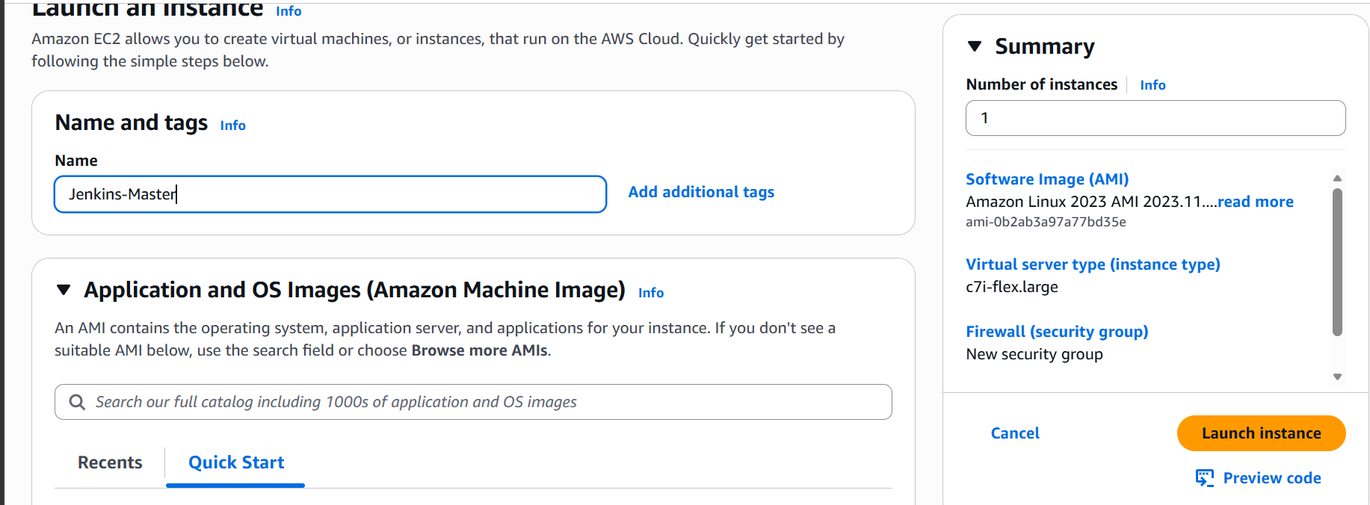
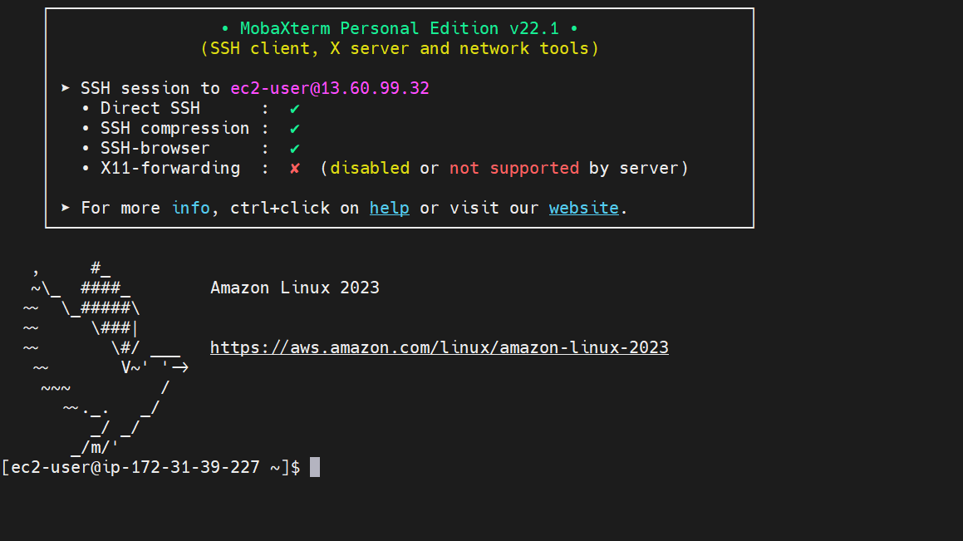
Ssh into Jenkins master
Install java
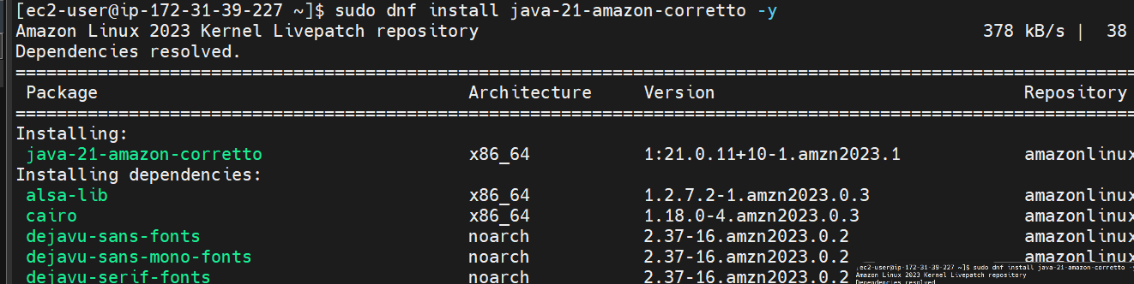

Download and install jenkins
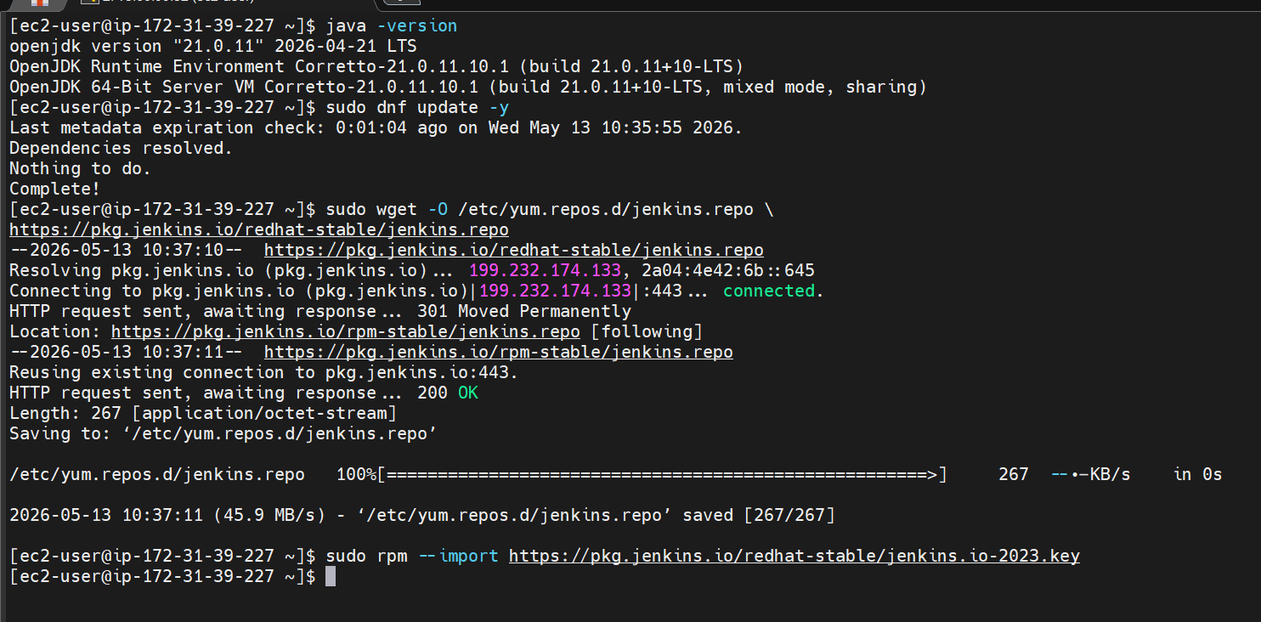
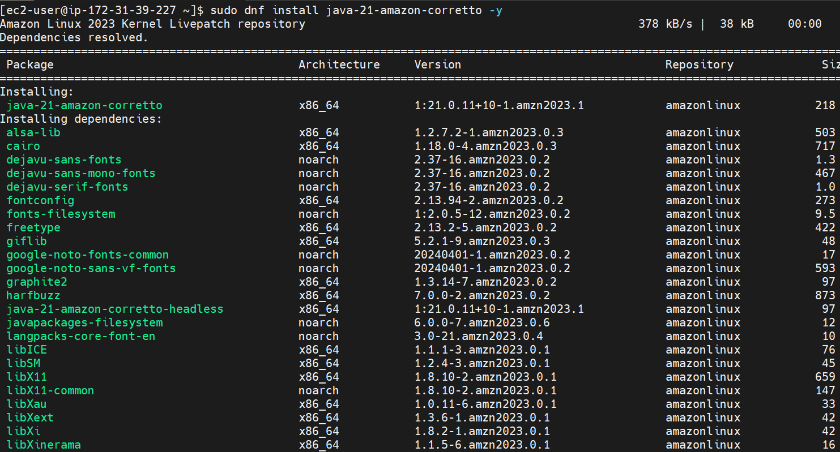
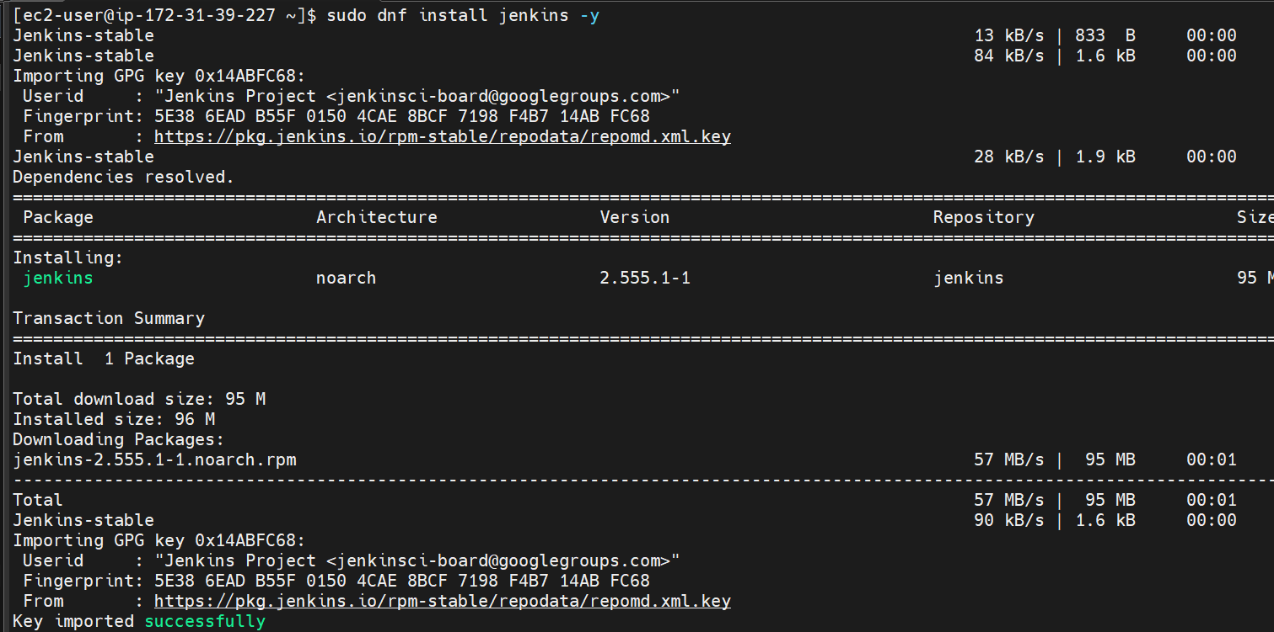
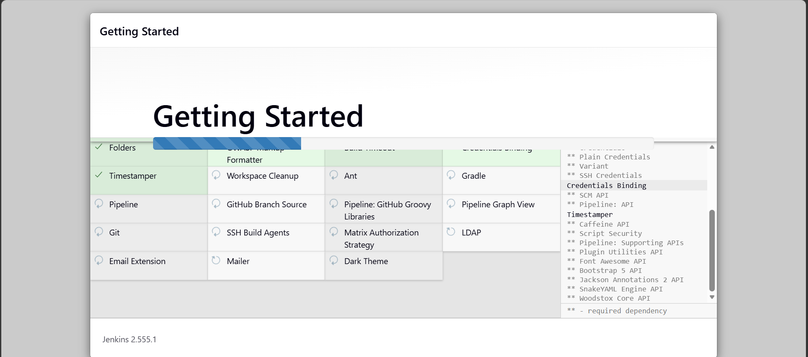
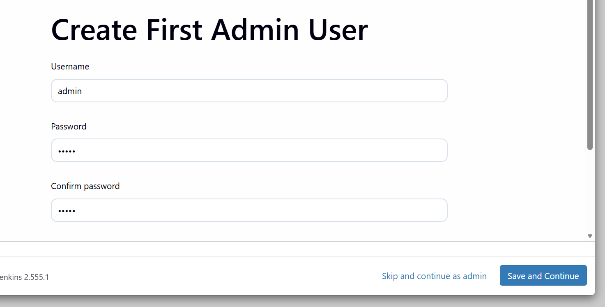
Jenkins setup on the master is done now lets configure the nodes
We have two nodes now lets ssh into both and do the configs
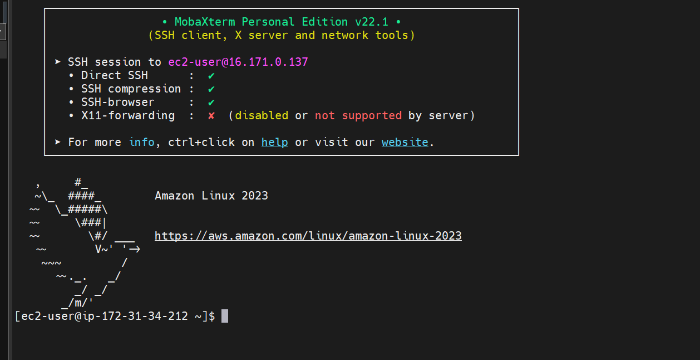
Logged in to slave 01
Installing java
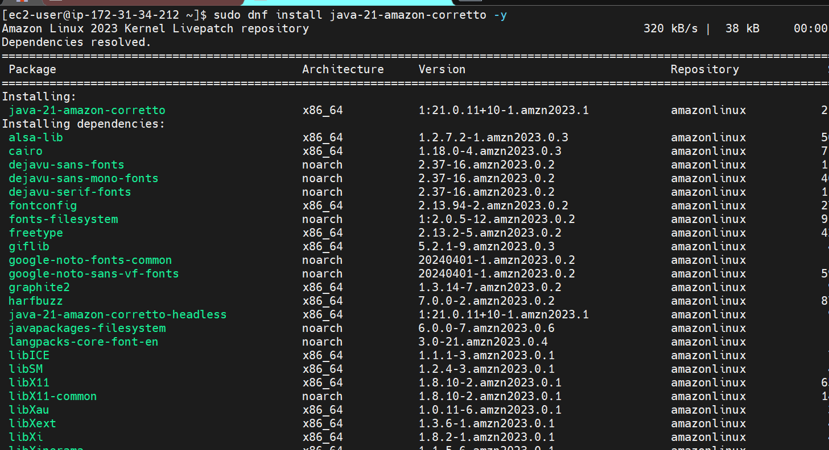
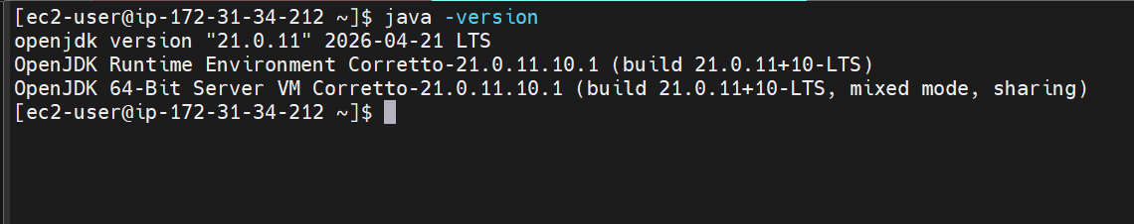
Creating Jenkins agent directory
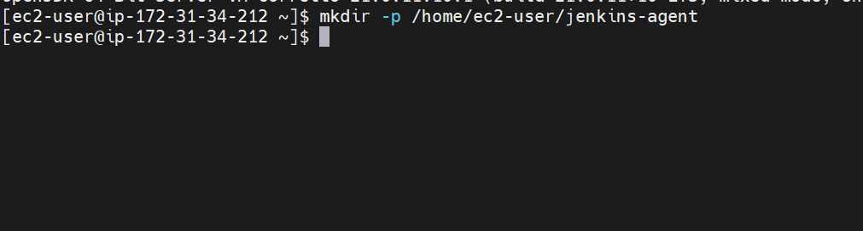

Now lets do the same in other node
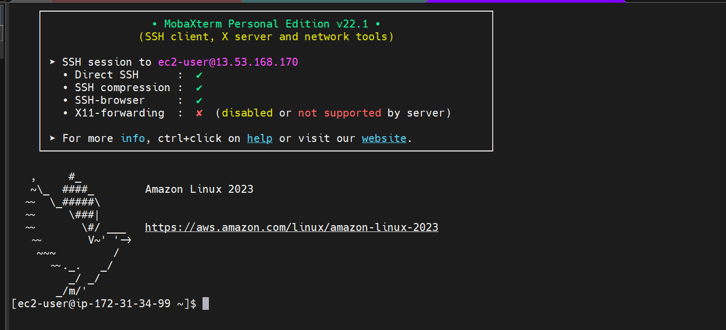

Logged in to slave 02
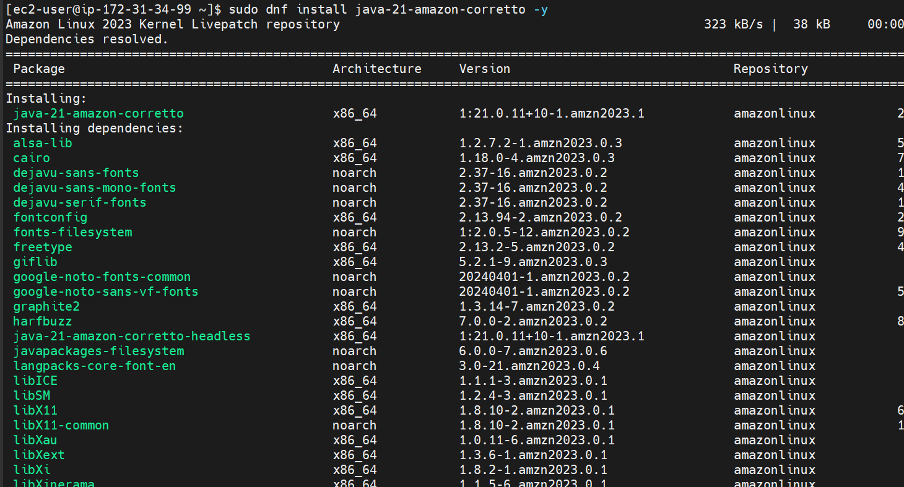

Java installation is done
Verifying the java version and creating Jenkins agent directory
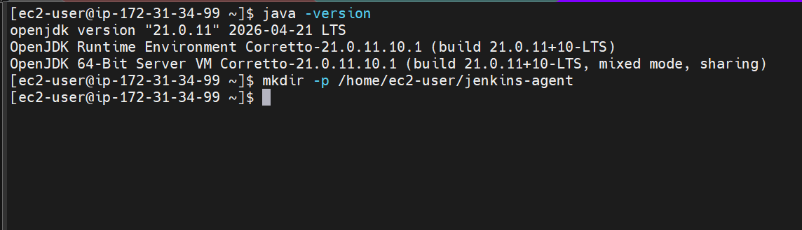

Now lets setup Jenkins master for ssh access
Go to master and create ssh directory and changing permissions
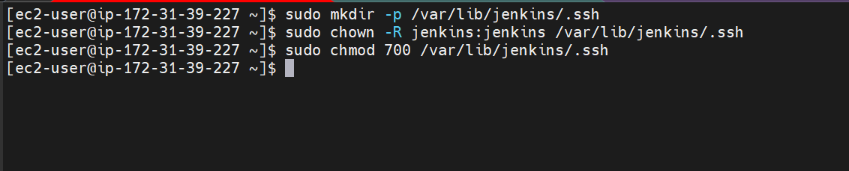

Now copy the pem key to Jenkins master
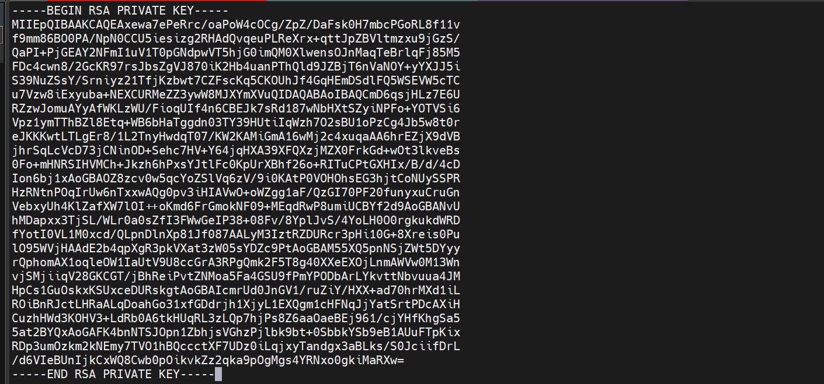

Setting up the permissions
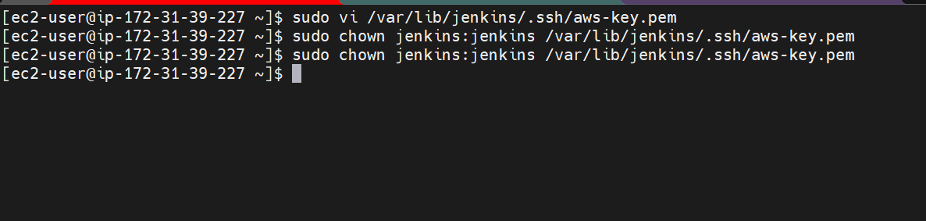
Now lets add the nodes to known hosts file
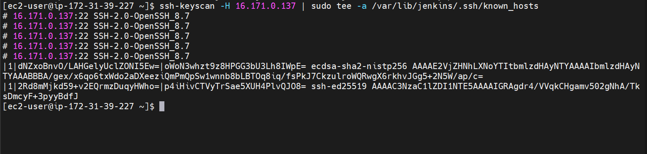
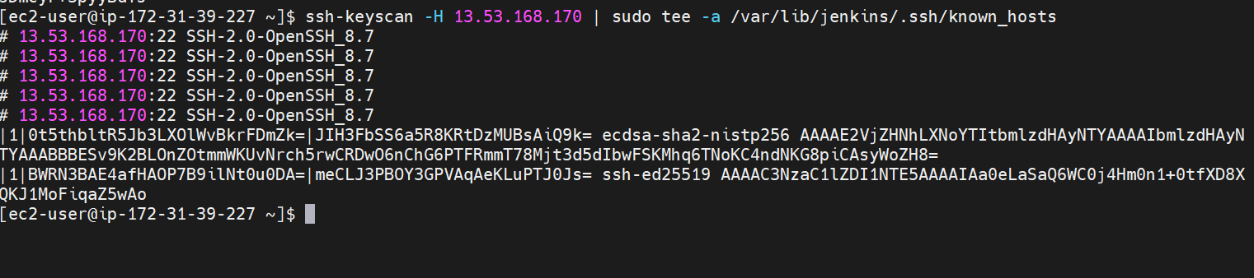
Added both the nodes to known hosts file

Changing permissions and ownerships
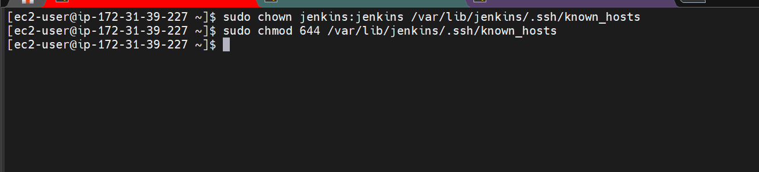
Now lets test the connectivity
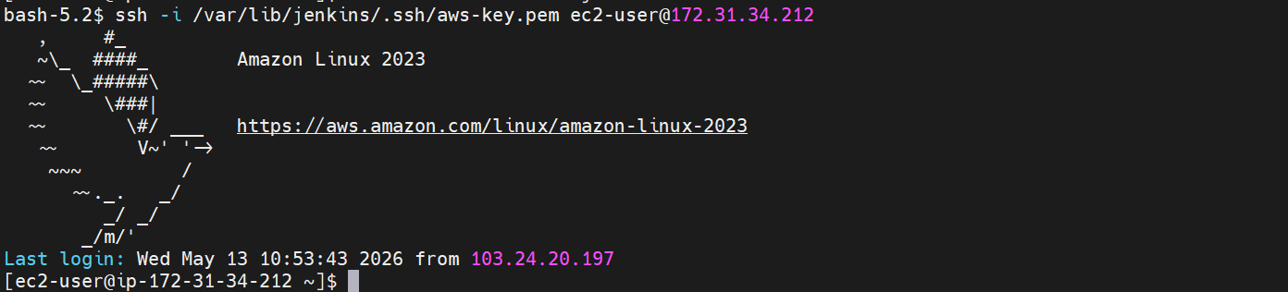 we are able to connect to node 01

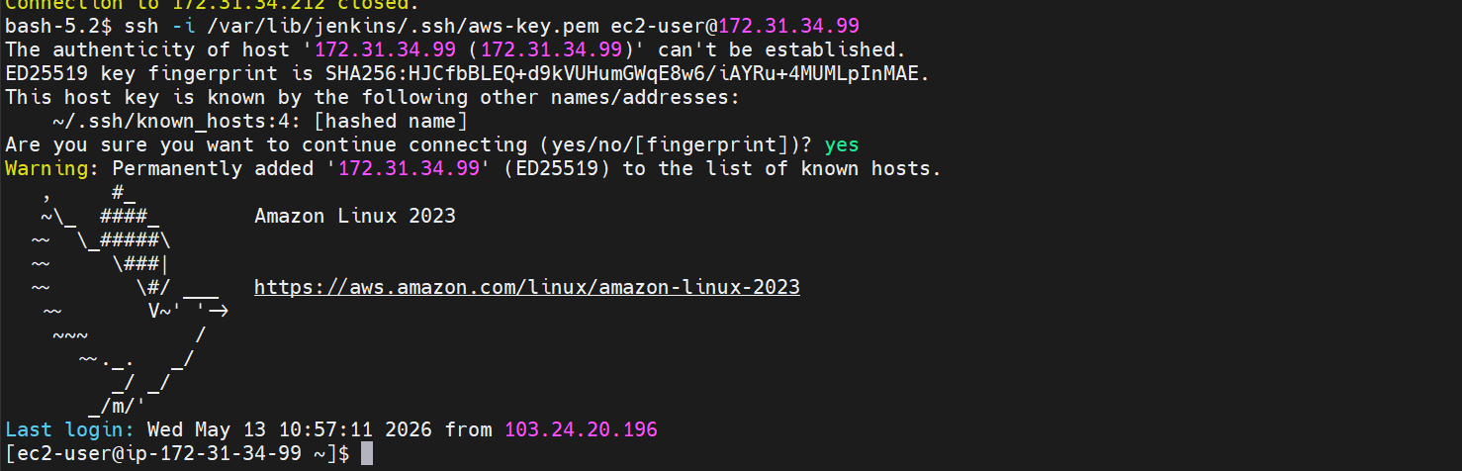

Connection succesfull to node-02 as well
Now lets go to the Jenkins GUI and add nodes
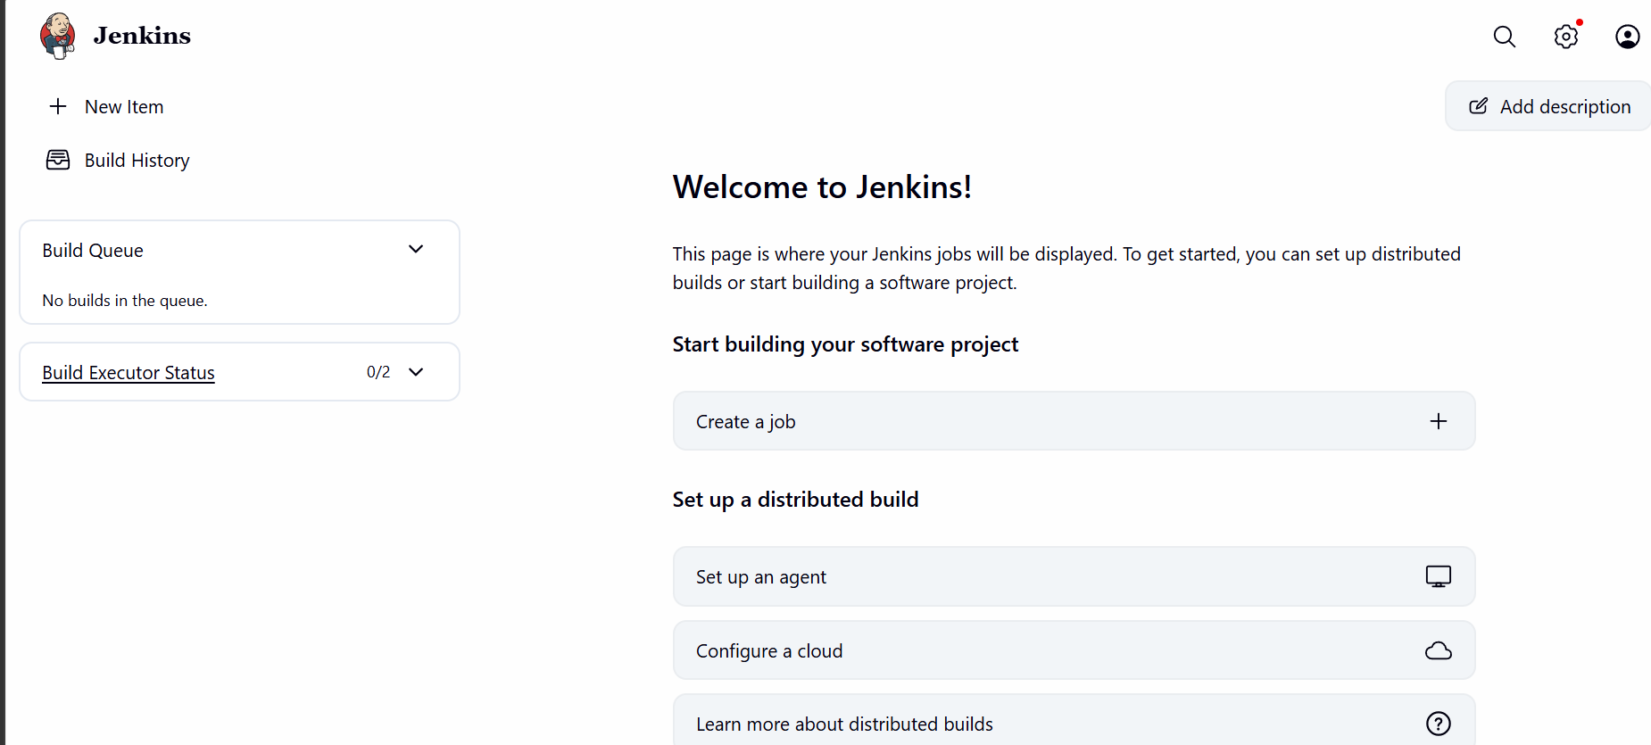

Go to manage Jenkins and select nodes
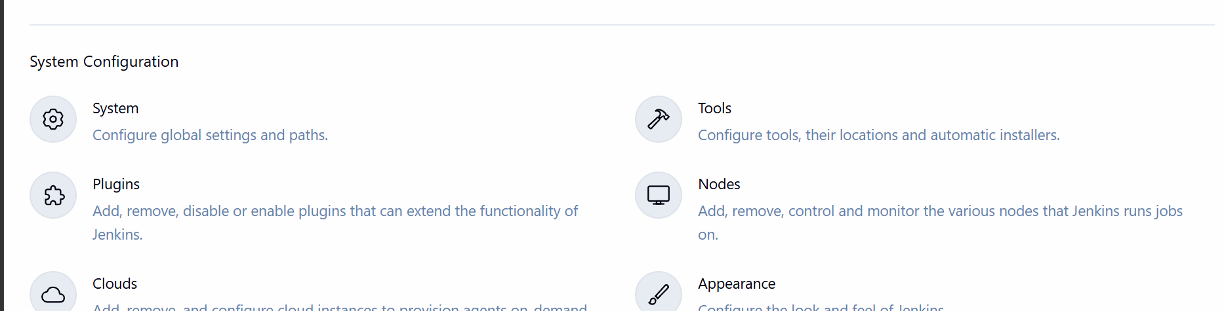
Click on add node
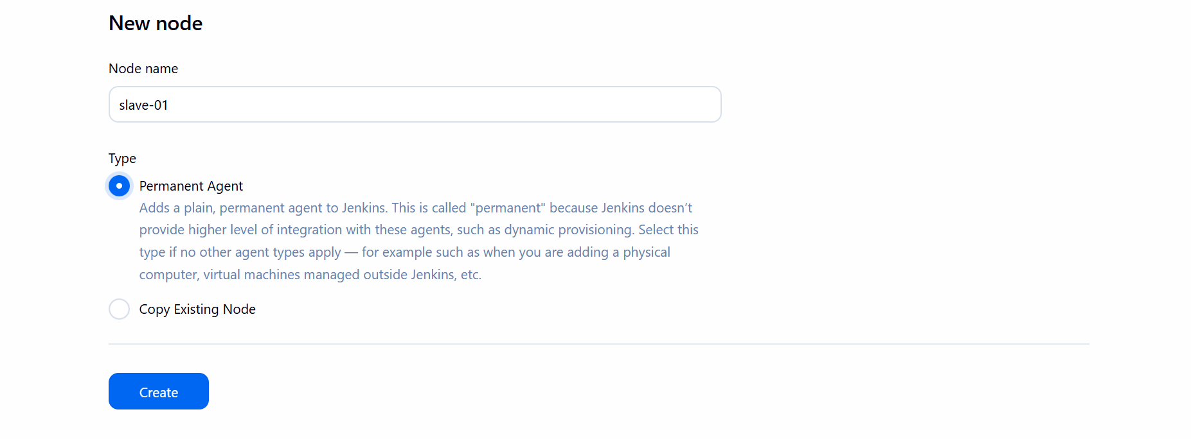

Click on create node

Give a name and set remote root directory
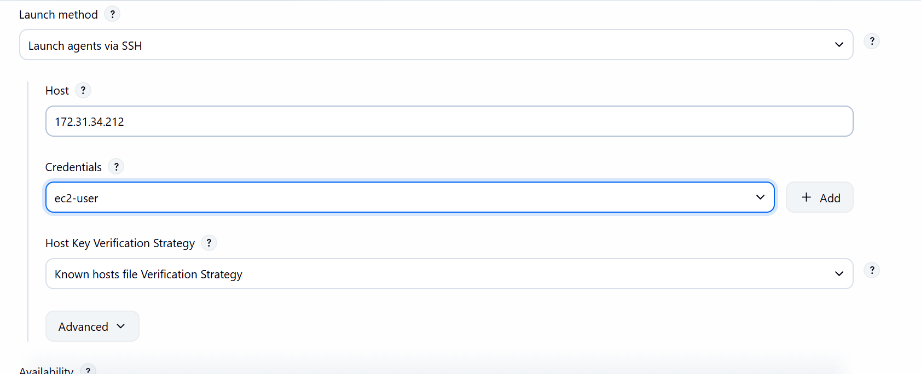
Click on launch via ssh
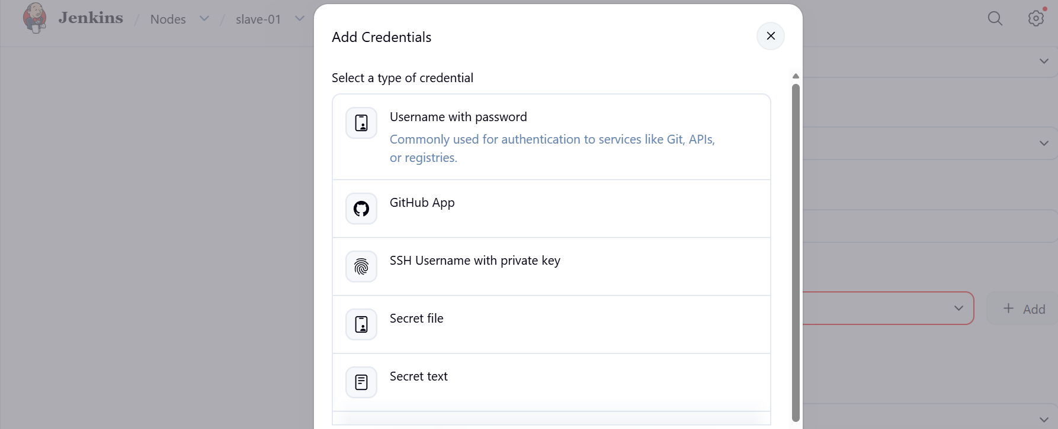
Click on ssh username with private key

Click on save
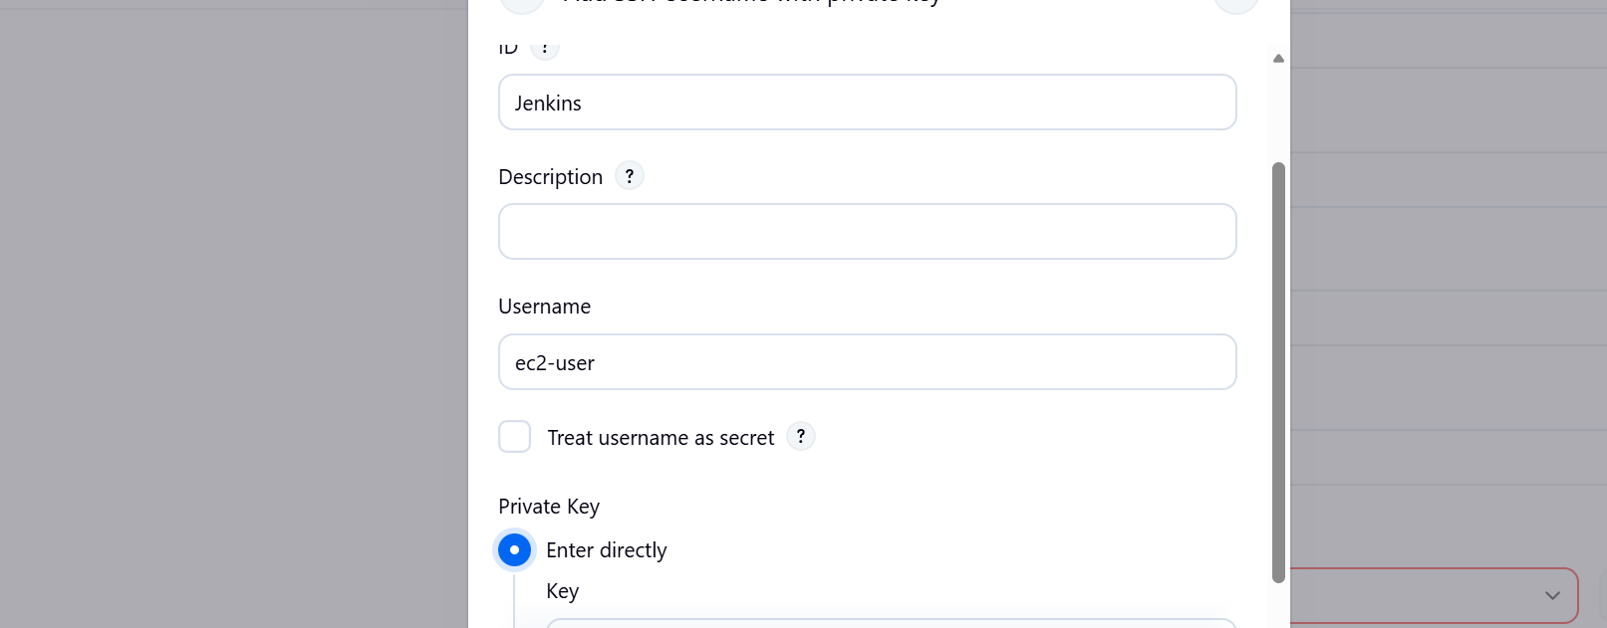

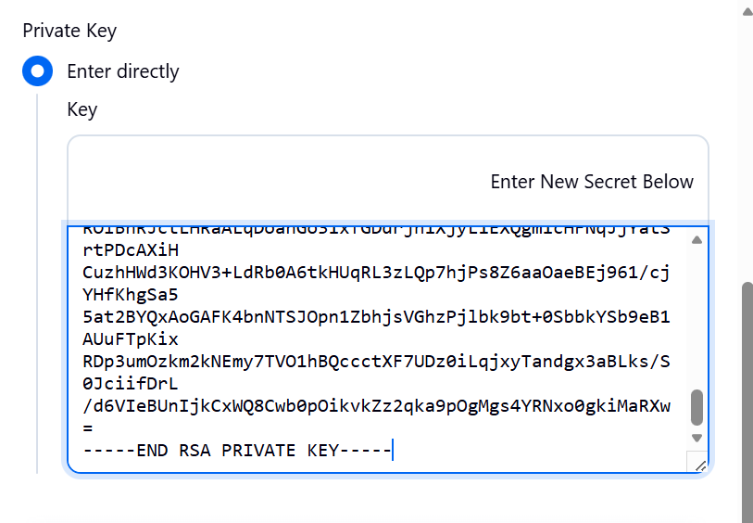

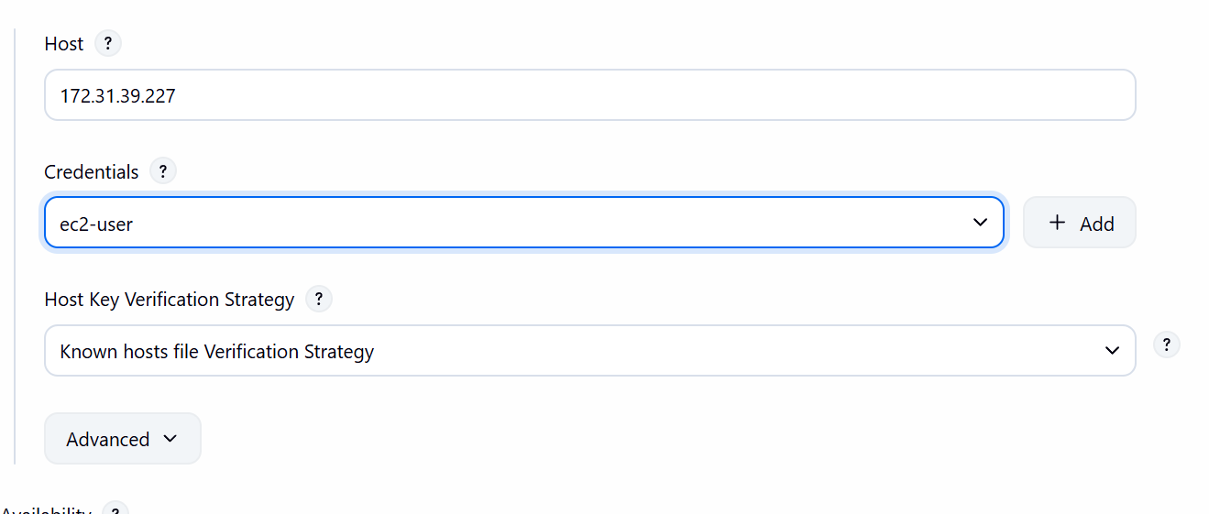

Save now
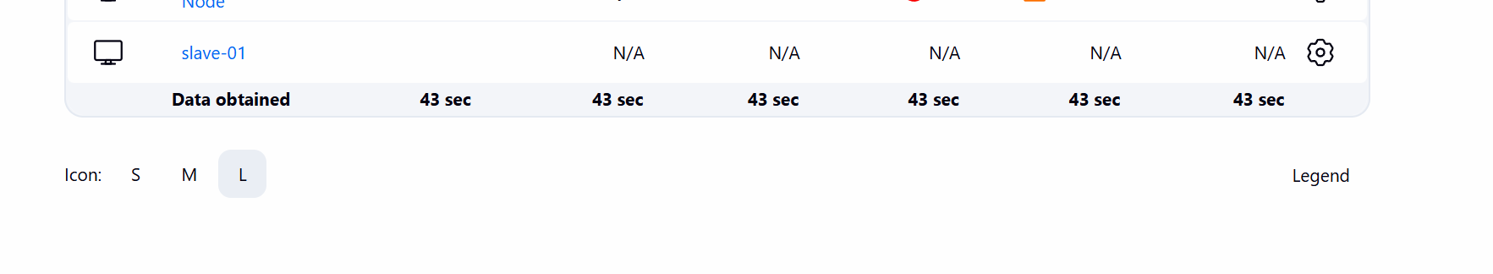our node is online now
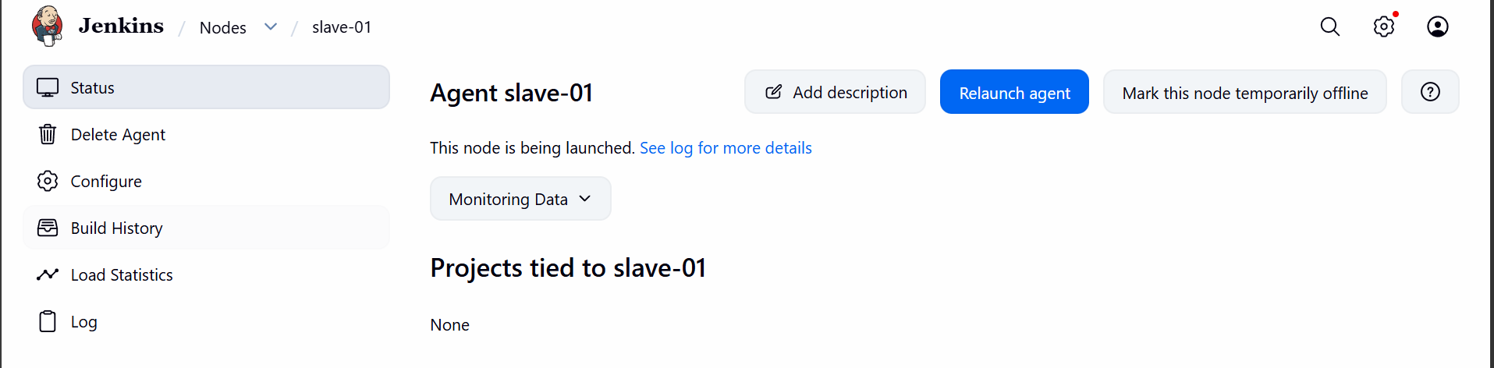

Now lets do the same for second node
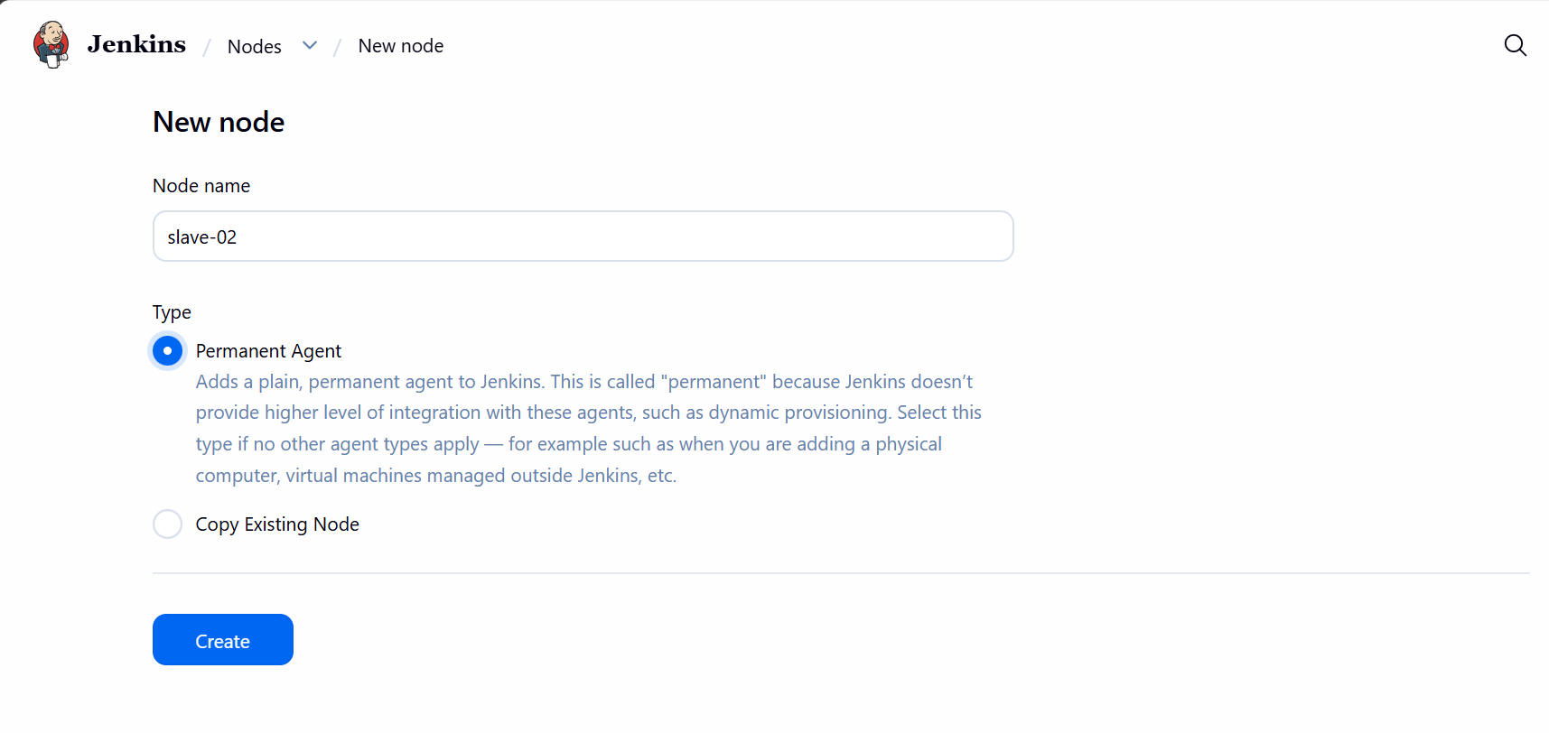
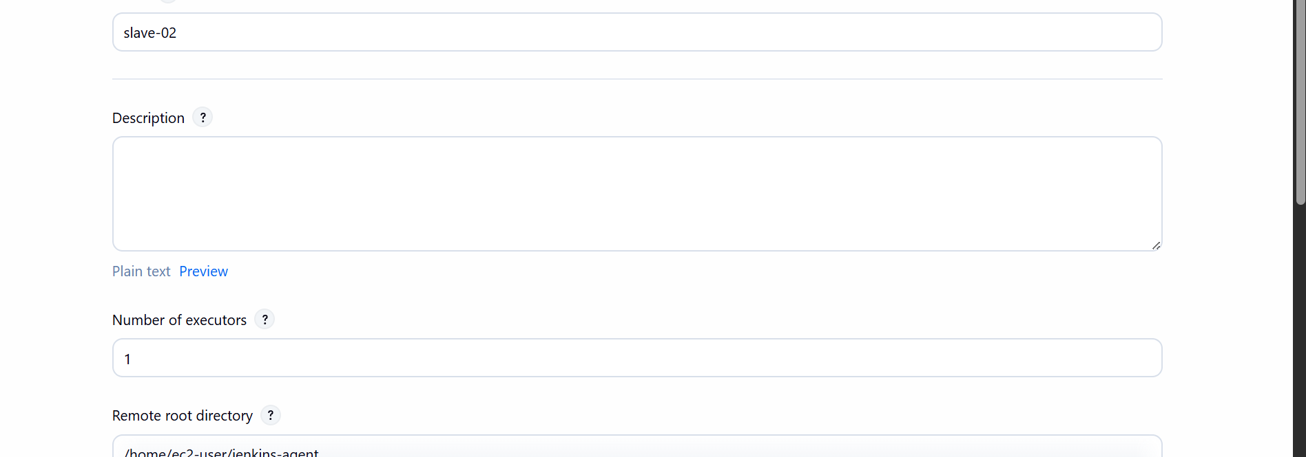
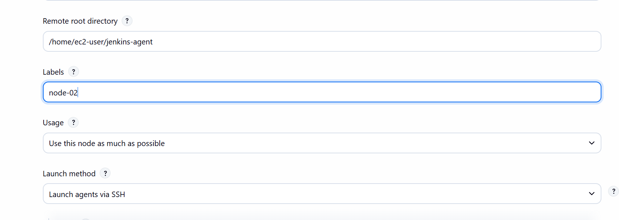
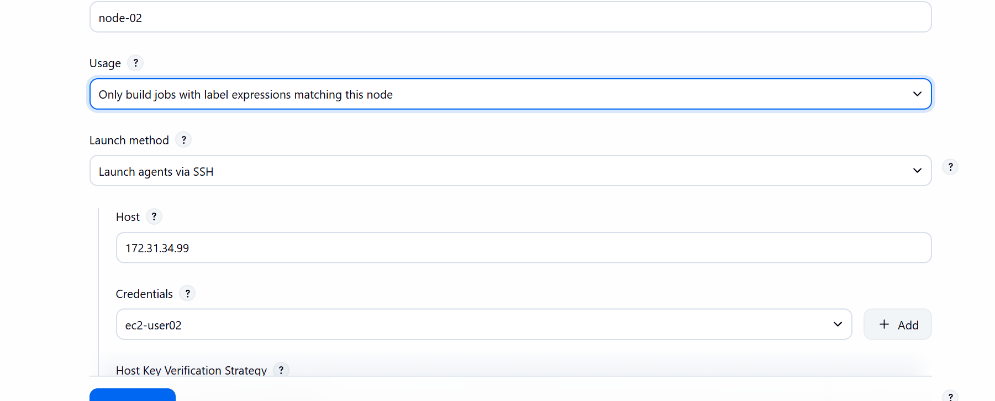

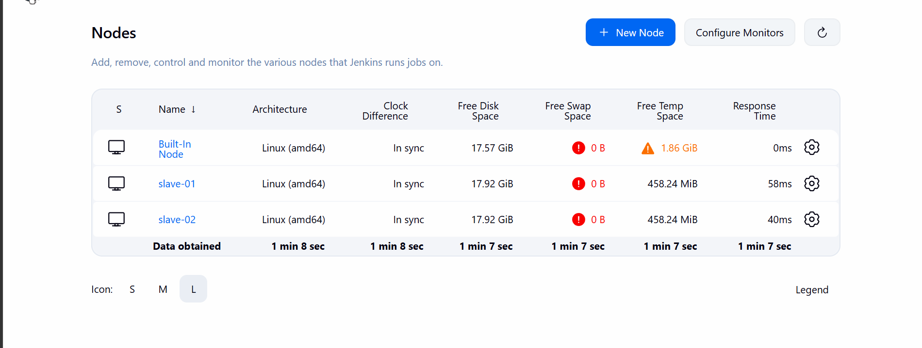

Now we have all the nodes online master and two slaves
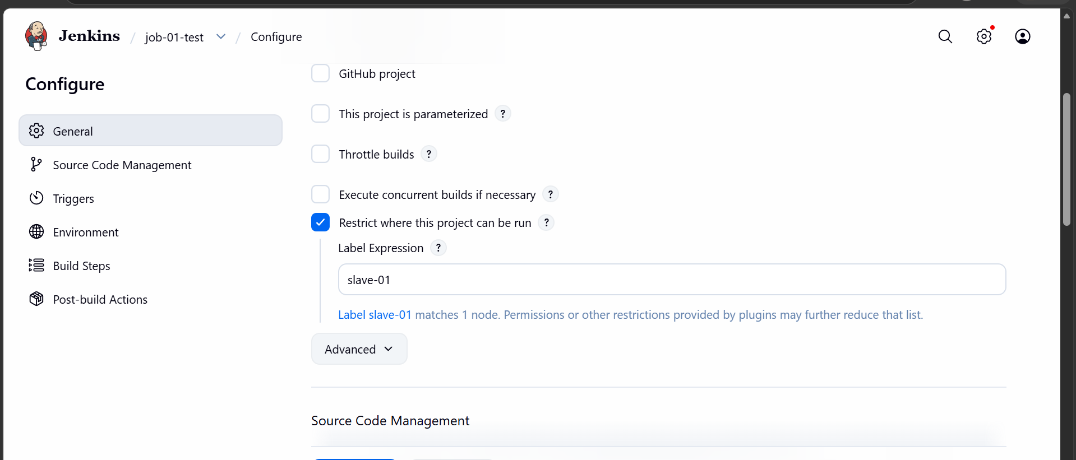

Running the build based on the label
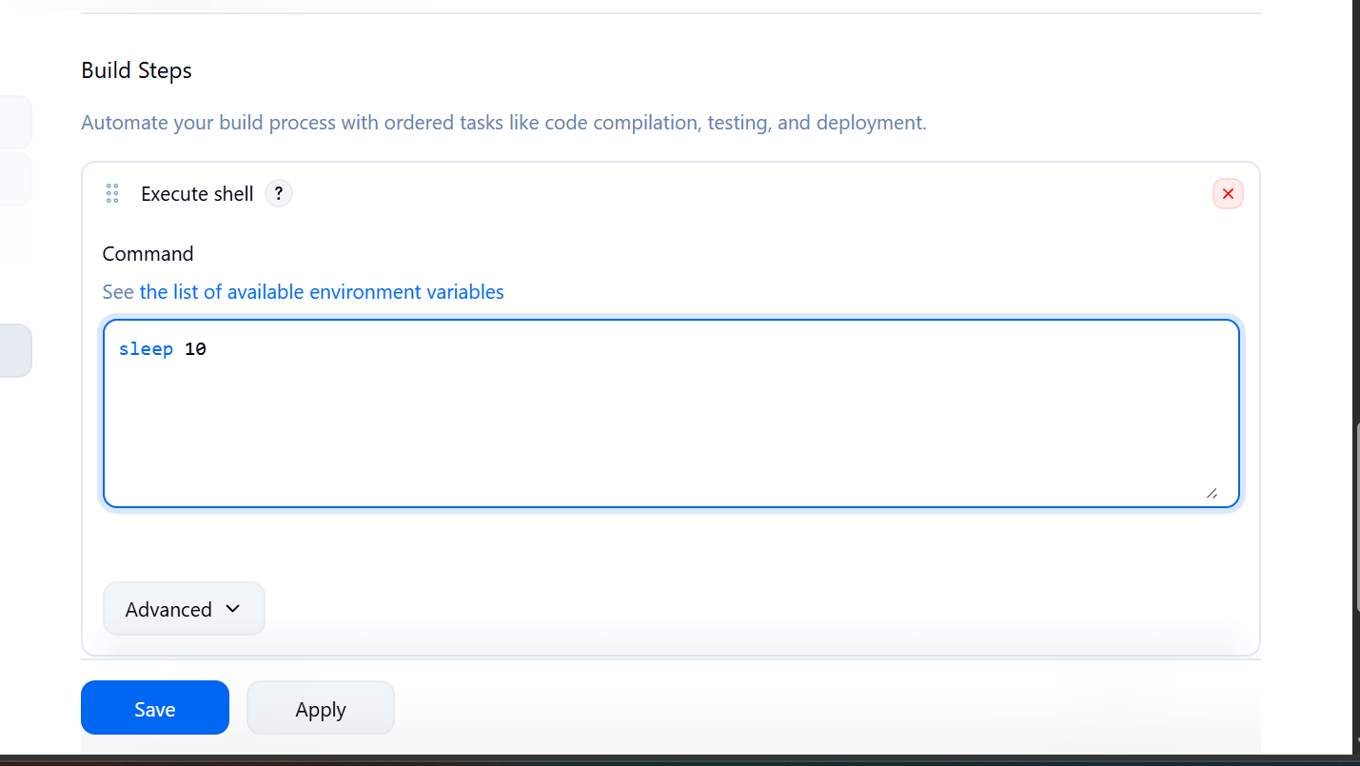
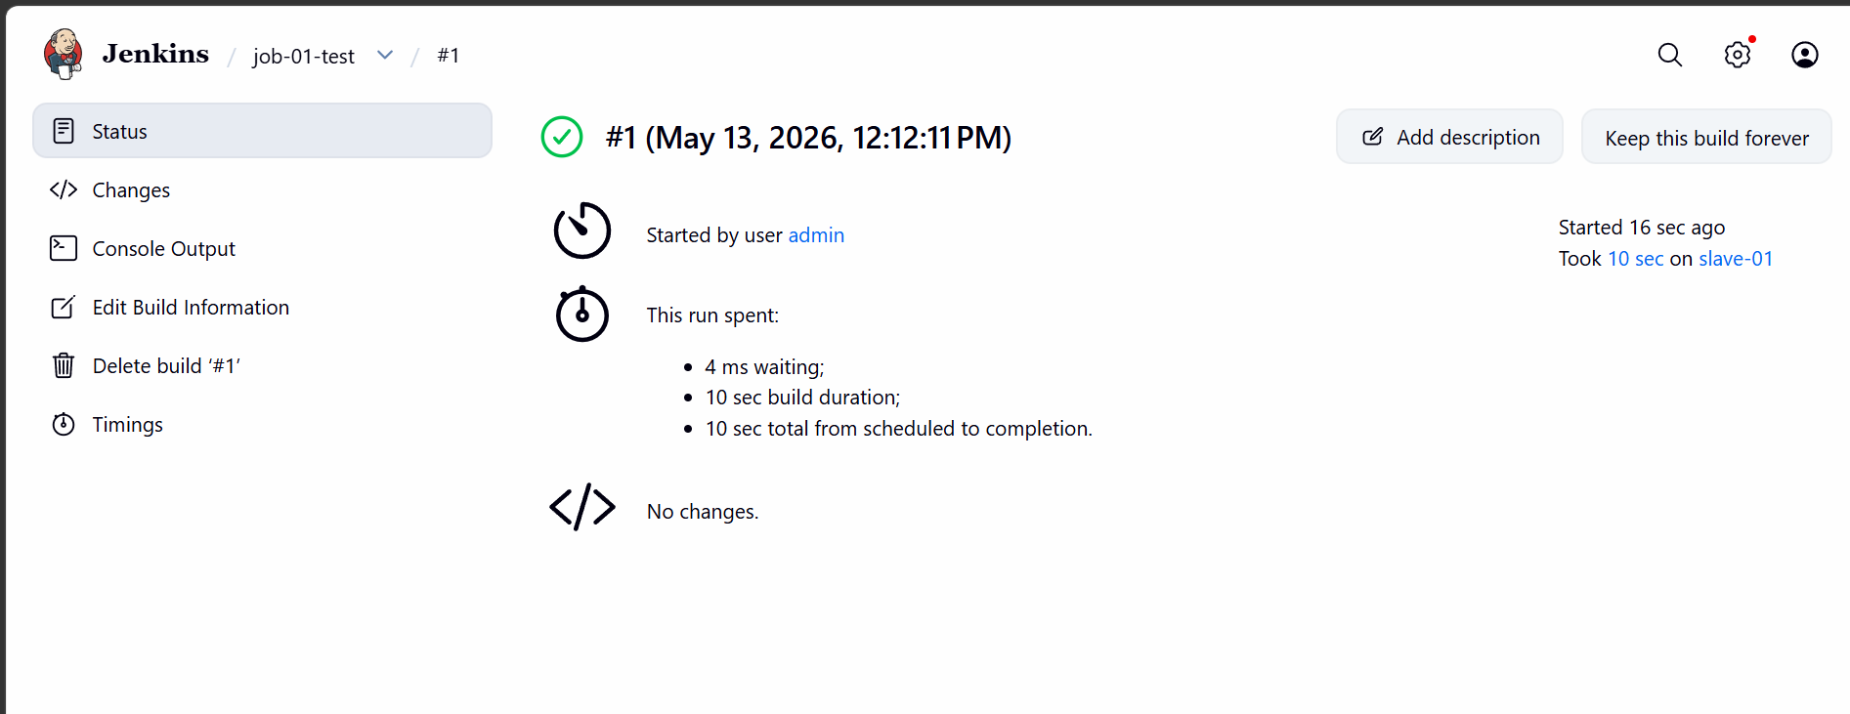

Build executed on slave 01
Creating one more job to test another label
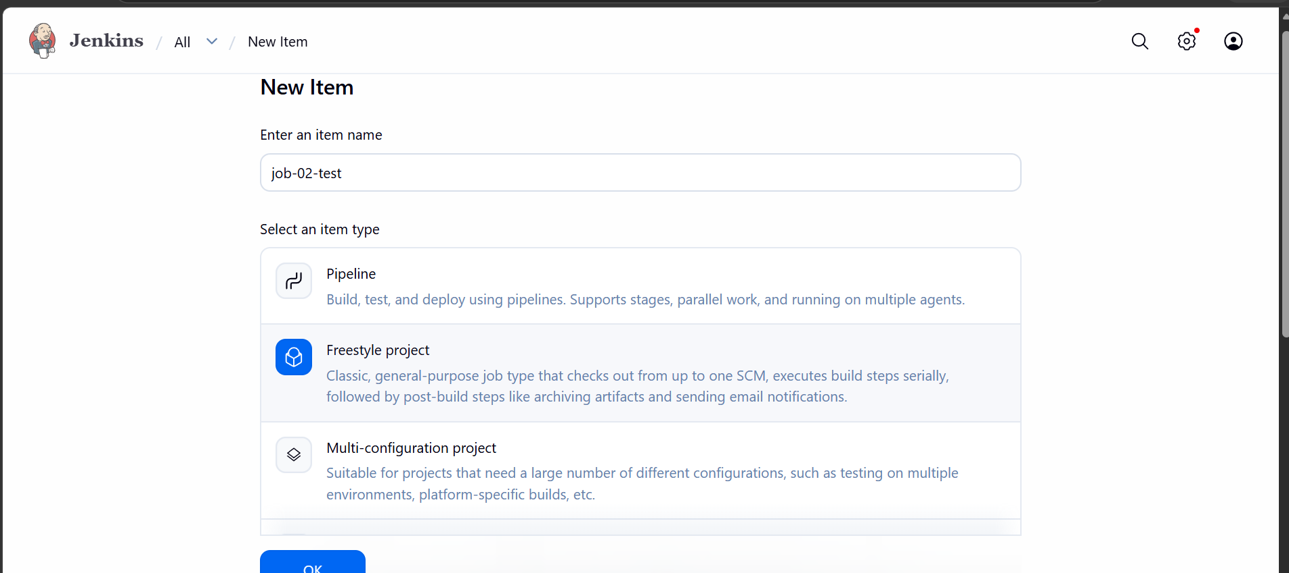
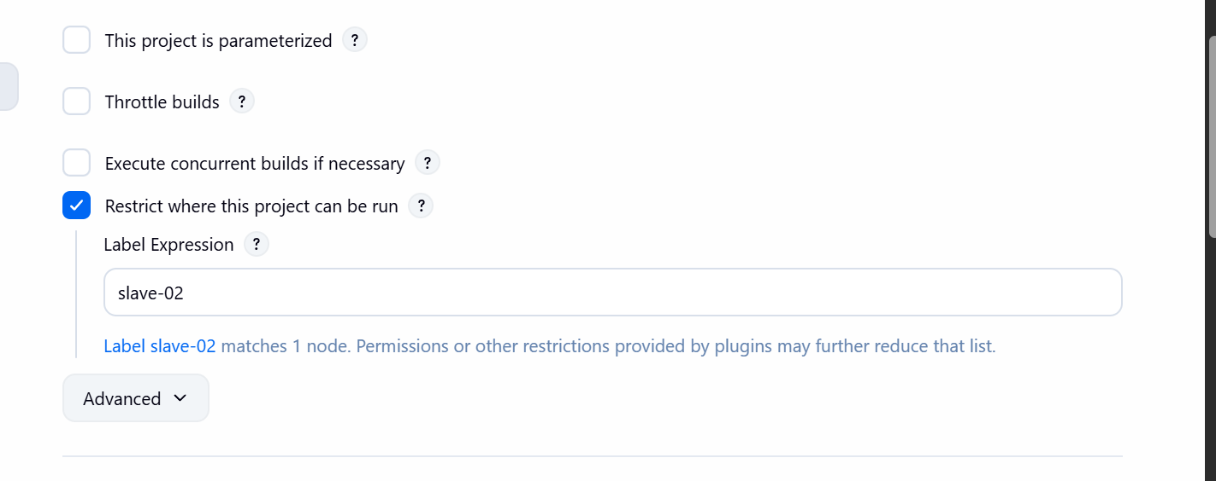
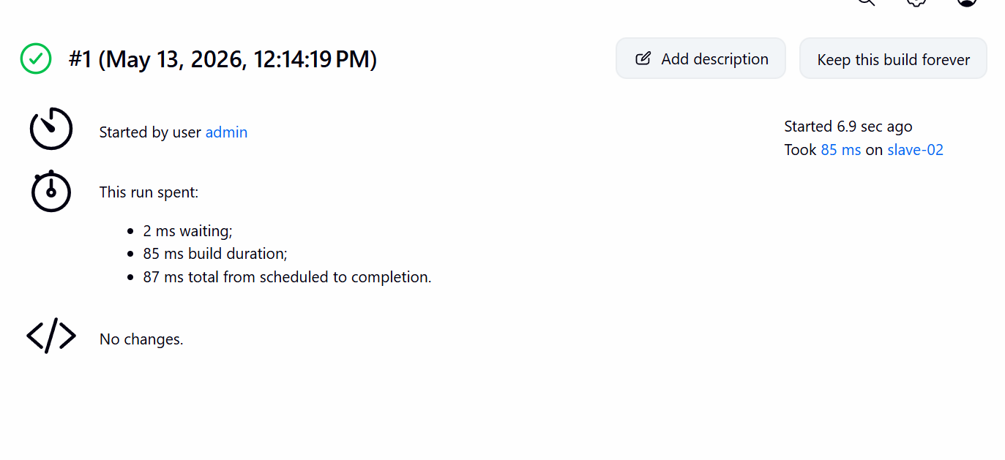
The second job ran on slave-02

